How to train your mind for analytical thinking?

[BUSINESS ANALYTICS](https://www.analyticsvidhya.com/blog/category/business-analytics/) [BUSINESS INTELLIGENCE](https://www.analyticsvidhya.com/blog/category/business-intelligence/)

SHARE

https://secure.gravatar.com/avatar/51bf7a2a1f2a0dd3a1012fa4cf5a9e80?s=48&d=mm&r=g [TAVISH SRIVASTAVA](https://www.analyticsvidhya.com/blog/author/tavish1/), JANUARY 26, 2014 / [12](https://www.analyticsvidhya.com/blog/2014/01/train-mind-analytical-thinking/#comments)

[](https://www.analyticsvidhya.com/blog/wp-content/uploads/2014/01/brain-exercise.png)

I recently started going to the GYM. Quite a big achievement for me to be going to the gym regularly for more than a month. What always made me irregular was a lack of motivation to go to the gym everyday. However, I made some key changes this time. For starters, I paid a personal trainer and tightly followed a diet schedule. In around 20 days I realized I was able to lift 3 times the weight and 1.5 times the repetitions of the same exercise. Did my muscles become thrice as strong as before? No, what my trainer played on was “the muscle memory”. Say, I lifted 10kg on a particular exercise yesterday and struggled to make 10 repetition, but somehow did it. Today, my muscle already knows I was able to complete 10 repetition on 10 kg. This time I struggle far less, because I am already prepared for what is coming.

Must Read: [Useful tools to improve structured thinking](https://www.analyticsvidhya.com/blog/2014/02/tools-structured-thinking/)

I realized that same logic applies with the power to think. If you make calculations on daily basis, your calculations become more reflexive and accurate. An average working person in weekday spends 25-30% of his time sleeping, 40-60% of his time working , 10% of time eating and 15-25% idle. In this busy world more than 50% of our idle time is spent on road. You can use this particular time to develop sharper reflexes on numbers. This article will illustrates some engaging methods that I use in this idle time to sharpen my brain reflexes.

Some examples :

Driving alone to office, sitting in a cab to airport ,and travelling in trains, metro or bus are boring . I, however, engage myself in small puzzle solving which not only engages me, but also sharpens my brain reflexes. Here I will take some puzzles which I solve everyday while on the way to the office:

**1. Escape cops :**

By far “the most interesting one” . Everyday, I am just in time to leave for office. If the traffic is heavy, it becomes sometimes inevitable to cross signal just after it turns red. But on some blind turns, you find the traffic police waiting for the next meat. Here’s what I did to predict the number of police standing on the blind turns. I took two attributes to predict whether I will find cops or not. These attributes were :

a. Day of the week

b. Pattern of cops on previous junctions

[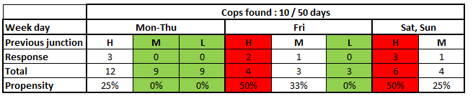](https://www.analyticsvidhya.com/blog/wp-content/uploads/2014/01/cops.png)

Using the above decision tree, I find a particular node, where I found almost zero probability to find a cop on blind junction. Till date, the algorithm works fantastically, but I am still figuring out better attributes to follow.

Must Read: [Learn the art of structured thinking and analyzing](https://www.analyticsvidhya.com/blog/2013/06/art-structured-thinking-analyzing/)

**2. Time to office :**

Here’s an interesting one again. It takes me 35 mins to reach office. But in case I get late for 2 mins at any particular road, I am almost able to calculate the exact time I can expect to reach the office. It’s simple but accurate. I have calculated the time it takes to cover each segment of the route and a factor in different scenarios of traffic at each segment. In total I have 7 check points at a difference of 5 mins. each in case of light traffic. Looking at the traffic in first segment gives me reasonable information to find the right multiplier for each of the segments.

[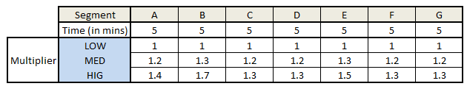](https://www.analyticsvidhya.com/blog/wp-content/uploads/2014/01/time.png)

Till date I have been able to predict the time to office within first 5 mins of drive in a confidence interval of +/- 3 mins.

**3. How fast is the other vehicles :**

This is the most addictive one. I always know my own vehicle’s speed and can judge the distance of approach of other vehicles in 10 seconds. Hence, I am able to calculate the relative velocity of other vehicle and, finally, the absolute velocity of the other vehicle.

[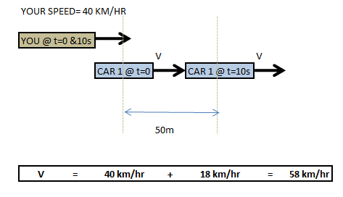](https://www.analyticsvidhya.com/blog/wp-content/uploads/2014/01/carss.png)

**4. Sizing of services we use :**

Whenever I take an auto-rickshaw, taxi or any other services, I try to calculate the total sizing of that business model and the profit individual players make in the process. I have had the most interesting conversation with the drivers, who always had some new insight on ground realities which I missed to incorporate while thinking of the business model. You can read my article on sizing problems here (<https://www.analyticsvidhya.com/blog/2014/01/tips-crack-guess-estimate-case-study/>). Even though the article focuses more on interview approach, you can leverage same framework to do the sizing of services on daily basis. Not only will you find it interesting but also you will improve your analytical skills.

Must Read: [5 habits of highly successful analysts](https://www.analyticsvidhya.com/blog/2013/09/5-habits-highly-successful-analyst/)

Potential benefits of implementing such practices:

Three basic benefits which I have realized by implementing such practices are as follows:

**1.  Power to innovate in problem statement and its solution:**

To bring an out of box solution, you always need an out of the box problem statement. As an analyst, I continuously feel the need to find fact based problems which can create significant impact. We are surrounded by facts, and to search for the right facts to build up implementable solution is what it takes to be a successful analyst.

When we do a regular search of such interesting problems, our reflexes to look at imperfections sharpens. We are more capable of  to think of new business cases which can become impact full projects.

**2. Sharpen the reflexes to calculate faster:**

Practice makes man perfect. It does so in two ways. First, your brain tends to retain some frequent calculations. Say, 1 million * 1000 = 1 billion. You don’t need to calculate the number of zeros because it gradually becomes very intuitive. Imagine thousands of such combinations right on the tip of your head. Engaging free time to make meaningful calculations for sure makes your calculative reflexes sharper.

**3. Think about the same problem in many angles and choose the most effective one:**

The puzzles can be very simple, but thinking the same puzzle with different methods and then comparison of different answers not only is interesting in nature but also helps you build on your evaluative skills. We gradually start to implement the same on complex scenarios.

End Notes:

 Most of my experiences which I shared in this article were implemented while I was not driving.Do try this practice and let us know of your exciting routine problems. Try to be innovative while defining a new problem. The more challenging is the problem more interesting will be your after thoughts.

Did you find the article useful? Share with us any other problem statements you can think of.Also share with us other techniques you use to keep your brain in its front foot.  Do let us know your thoughts about this article in the box below.

# Tools for improving structured thinking (for analysts)

[BUSINESS ANALYTICS](https://www.analyticsvidhya.com/blog/category/business-analytics/) [BUSINESS INTELLIGENCE](https://www.analyticsvidhya.com/blog/category/business-intelligence/)

SHARE

https://secure.gravatar.com/avatar/4881b6eff4a916300c9a785c9f103f24?s=48&d=mm&r=g [KUNAL JAIN](https://www.analyticsvidhya.com/blog/author/kunalj/), FEBRUARY 27, 2014 / [6](https://www.analyticsvidhya.com/blog/2014/02/tools-structured-thinking/#comments)

There are 4 ingredients required to make  an awesome business analyst:

1. Passion for Business Analytics
2. Structured thinking
3. Love for statistics and numbers
4. Business domain  knowledge

[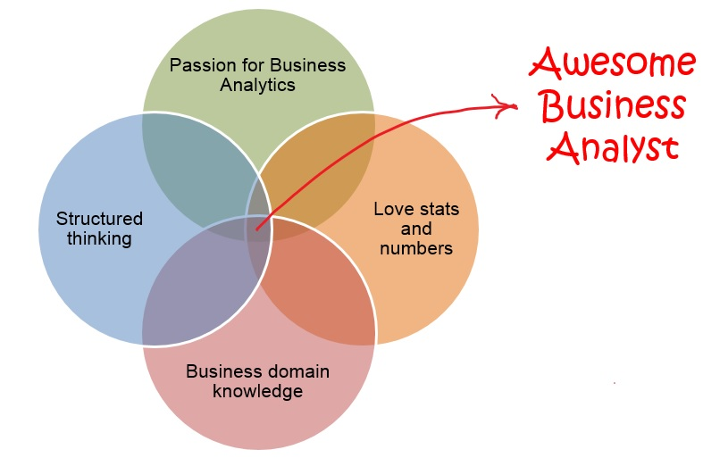](https://www.analyticsvidhya.com/blog/wp-content/uploads/2014/02/awesome_business_analyst.jpg)

We recently shared a few [tips to train your mind on analytical thinking](https://www.analyticsvidhya.com/blog/2014/01/train-mind-analytical-thinking/), the tactics and practices mentioned there improve your number crunching abilities and help you apply analytical thinking in day to day activities. Today, I am going to share a few tools and exercises I use for improving structured thinking.

**What is structured thinking?**

Structured thinking is a process of putting a framework to an unstructured problem. Having a structure not only helps an analyst understand the problem at a macro level, it also helps by identifying areas which require deeper understanding.

I had written an article on [how structured thinking can help](https://www.analyticsvidhya.com/blog/2013/06/art-structured-thinking-analyzing/) an analyst by reducing iterations and turn around time on projects. Today I’ll share some tools and practices which have helped me immensely in improving my structured thinking.

**Tools / Exercises for improving structured thinking:**

Following are some of the best practices I have used and applied for better structured thinking. I am sharing simple tools rather than the most sophisticated mind map software out there. Idea is to get you started on this habit of structured thinking. Once you are used to the process, you can explore advanced tools and software:

1. **Layout a framework on paper before looking / creating your datasets:**

If there is only one takeaway you want to carry from this article, it should be this. As a practice, you should spend 1 – 2 hours of distraction free time (no emails, messages and phone calls!) just laying out the structure, possible hypothesis, story flow and a tentative business presentation. Here are a few pics of how I typically layout structure and story flow on paper (Business problem statement: Your Organization has observed increased credit risk in last few months. You need to analyze why this has happened and recommend next steps):

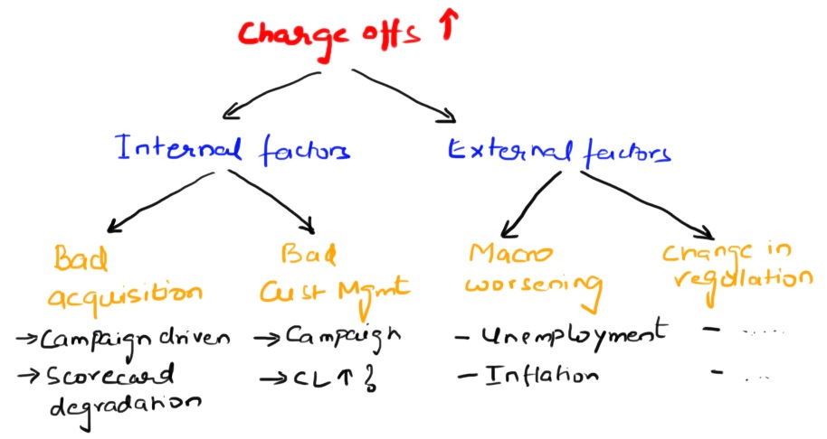

Putting framework on paper

Here is how tentative story looks at this stage:

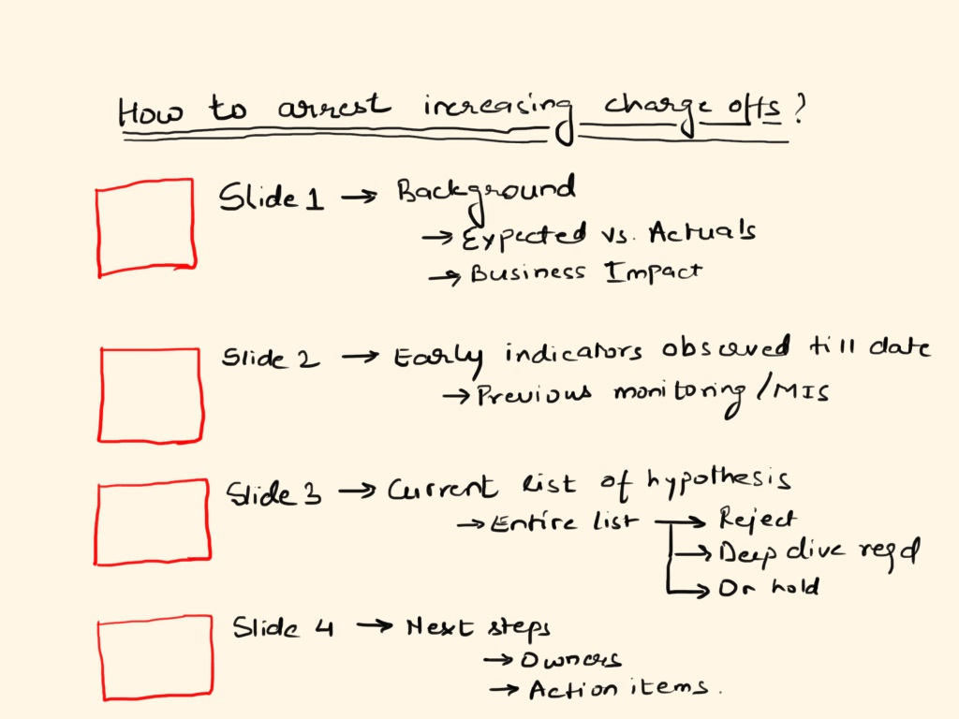

Tentative presentation flow

**2. Use whiteboards for brainstorming (again before touching the data):**

Typically, I do a session / meeting with stakeholders laying out all possible hypothesis and action items after I have spent time laying out things on paper. Call all stakeholders, layout discussion for them, make sure they are engaged (and not busy on smartphones), note thoughts on whiteboard and capture all the thoughts in the framework we created on paper (before this brainstorming).

By end of this brainstorming, you should have a clear framework agreed and discussed with stakeholders.

**3. Practice back of the envelope calculations (anywhere and everywhere):**

This is the tool I use the most. Any business you come across (e-Commerce websites to the laundry service you might be using), try and chalk out their business model in your mind. Some of the questions you can use to get yourself started are:

* What would be the revenues this business might be making?
* How many customers are they touching? Repeat customers? Loyalty scheme?
* What would be the cost structure?
* How has the business scaled up / down in last few months / years?

Perform all these calculations at back of your mind (and not on paper). Layout a structure in your mind first, then answer these questions and come up with answers. A side benefit of doing this is that you improve number crunching abilities as well.**note / document to conduct meetings / discussions:**

This is one of the tricks one of my mentors used to enforce on his team. As a rule, he did not look at any powerpoint presentation. For doing any discussion with him, you were enforced to create a note explaining the problem and the solution, send it to him before hand and then he would get involved in discussion. I think (am not completely sure), a similar practice is followed in Amazon for all meetings with Jeff Bezos.

If you have not tried this before, give it a shot. You will realize the amount of clarity which comes by preparing a simple note!

These tools and tricks have served me well over years. Do let me know in case you have any trick / tools, which have helped you become more structured in your thinking.

# The art of structured thinking and analyzing

[BUSINESS ANALYTICS](https://www.analyticsvidhya.com/blog/category/business-analytics/)

SHARE

https://secure.gravatar.com/avatar/4881b6eff4a916300c9a785c9f103f24?s=48&d=mm&r=g [KUNAL JAIN](https://www.analyticsvidhya.com/blog/author/kunalj/), JUNE 24, 2013 / [10](https://www.analyticsvidhya.com/blog/2013/06/art-structured-thinking-analyzing/#comments)

It took me 3 months to complete my first analytics project. If I would have worked on a similar project 6 months into the job, I would have completed it with in a month. Today, I can complete the same project in less than a week.

## **So what has changed during this time?**

* I have started thinking in structured manner
* I have gained experience in best data management practices
* My business thinking has evolved over time

While the last two points improve only with time, structured thinking can improve quickly through simple training and disciplined approach towards analysis.

But before we go forward, let me bring out the benefits from structured thinking through following graph:

[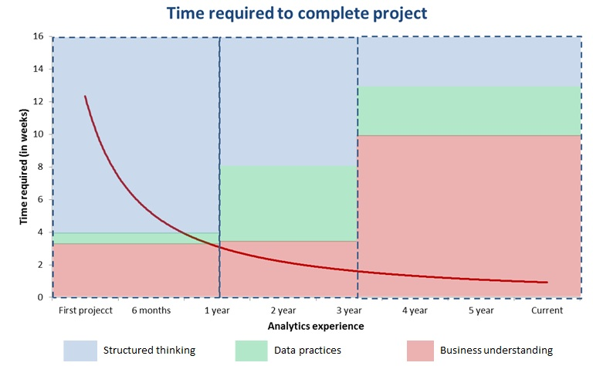](https://www.analyticsvidhya.com/blog/wp-content/uploads/2013/06/time-required-project-completion.jpg)

Here is how to read this graph:

* Red line in the graph shows how time to complete a project (in weeks) has come down with experience
* With in each of three blocks (< 1 year; 1 – 3 year; 3+ years), the area of color shows the factor responsible for drop in time.
* For example, during the first block, time required to complete the project comes down from 12+ weeks to 3 weeks and 75% of this drop is because of structured thinking.

As you can see, structured thinking is a a big differentiator between a good analyst and bad analyst. Not only this, you can not become a good analytics manager until you can put structure to complex and ambiguous problems. Hence, this post is aimed to help you progress on path of structured thinking.

**What is structured thinking?**

Structured thinking is a process of putting a framework to an unstructured problem. Having a structure not only helps an analyst understand the problem at a macro level, it also helps by identifying areas which require deeper understanding.

**Why is it important and how can it help?**

Without structure, an analyst is like a tourist with out a map. He might understand where he wants to go (or what he wants to solve), but he doesn’t know how to get there. He would not be able to judge which tools and vehicles he would need to reach the desired place.

How many times have you come across a situation when the entire work had to be re-done because a particular segment was not excluded from data? Or a segment was not included? Or just when you were about to finish the analysis, you come across a factor you did not think off before? All these are results of poor structured thinking.

Following are some results of poor structured thinking:

* Multiple iterations of work
* Change of scope and work half way through
* Longer turn around time
* Difference in expectation between analyst and stakeholders

**So how to enhance structured thinking?**

Following are some of the best practices which I have learned over time. These practices have helped me and a lot of other people immensely to structure our thoughts and making sure we stay on track during our projects:

* **Create a Scope of Work document**: This document helps by bringing all stakeholders on same page at the start of any project. A typical document can be any where between half a page to maximum of 2 pages. Following are typical sections which I keep in this document:
  + Background
  + Problem statement
  + Customers, Sponsor and stakeholders
  + In scope and out of scope areas (please note that both are equally important).
  + Reference to any work which has happened in past

Once you create this document, make sure you circulate it to all stakeholders and take their thought at this stage only. If their is any confusion or contradiction to the scope, sort it out now! There is hardly any point in going further, until you define the scope clearly.

* **Create presentation and lay out the analysis without touching the data:**You will be surprised to see the power of this technique. It might sound counter-intuitive to people outside analytics industry, but this technique helps you remove any biases and makes sure you think of all the aspects before you zero in on any specific area. For example, if I want to understand why charge offs have increased suddenly in credit card portfolio over last month, I would lay it down in a structure similar to this:

[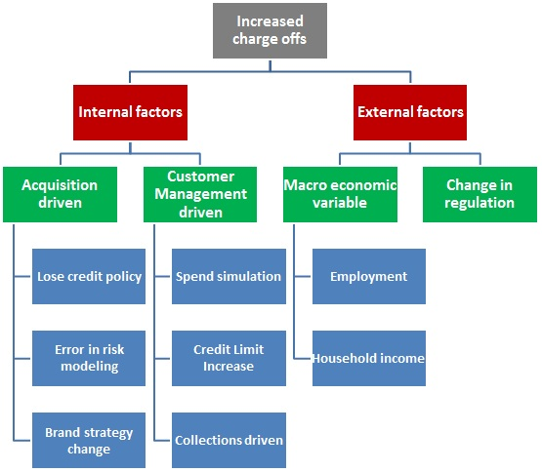](https://www.analyticsvidhya.com/blog/wp-content/uploads/2013/06/structure.jpg)Once this structure is exhaustive and complete, you can simply plug in the data for each set of variables and see what is the reason.

The beauty of this practice is that you can layout any problem by spending an hour on it. If you do this right, solving the problem would then be a simple walk through. If you don’t, there is a big risk that you might focus on only internal factors (that too only from a specific area).

* **Perform back of the envelope calculations:** Once you have the entire structure laid out, perform quick and dirty back of the envelope calculations to see if some things should be analyzed first or can be removed. As long as they are 80% right, go ahead. For example, if charge offs have doubled with in a month, it is unlikely to be driven by unemployment (unless you are aware of huge scale layoffs in the economy). Similarly, if Credit limit increase only impacts 2% of your portfolio, the charge offs from this programme need to increase by 50x, if portfolio risk has doubled, which is unlikely unless you have given free Credit without looking at population.
* **Layout the data requirements and hypothesis before looking at what data is available:** If you layout these after looking at what is available, there is a high chance that you restrict your thinking to those variables and data points which may not bring out the best outcome.
* **Finally… practice, practice and practice:** There is no point reading all this stuff, if you don’t apply it (too bad that I am saying it so late)! The more you apply it, the better you will become at it. Take any problem / business scenario, break it down on a piece of paper, see how things add up. How much profit or loss can you expect from a strategy change? What is the most critical factor? What assumptions need to hold out in order to make profits? Just apply structure to any problem you come across and see the fun. In matter of hours, you might know more than the  owner of the problem.

So, next time when you come across a problem to solve, don’t dive into the data. Put a structure around it, make sure you cover all the aspects, understand what is the most important factor, layout possible hypothesis and data requirements and then solve the problem. You will be surprised to see the reduction in time, if you follow these steps religiously.

As usual, if you know of any other practice, which has helped you think more structurally, do let me know.

# Five habits of highly successful analysts

[BIG DATA](https://www.analyticsvidhya.com/blog/category/big-data/) [BUSINESS ANALYTICS](https://www.analyticsvidhya.com/blog/category/business-analytics/) [BUSINESS INTELLIGENCE](https://www.analyticsvidhya.com/blog/category/business-intelligence/)

SHARE

https://secure.gravatar.com/avatar/4881b6eff4a916300c9a785c9f103f24?s=48&d=mm&r=g [KUNAL JAIN](https://www.analyticsvidhya.com/blog/author/kunalj/), SEPTEMBER 28, 2013 / [7](https://www.analyticsvidhya.com/blog/2013/09/5-habits-highly-successful-analyst/#comments)

I have interacted with various successful analysts over last 7 years. During these interactions, I found out some common habits in them. After observing these habits, I have tried ways to inculcate these habits myself. Some of these habits were also emphasized by my mentors, while the others were learnt the hard way!

This article lays down 5 habits I have observed in highly successful analysts and provides some of the ways in which I practice these habits. On one hand, I hope that some one should have made me aware of these habits at start of my career and the long lasting impact these could have. On the other hand, these habits have helped me immensely and I hope they will do the same for any one adapting them:

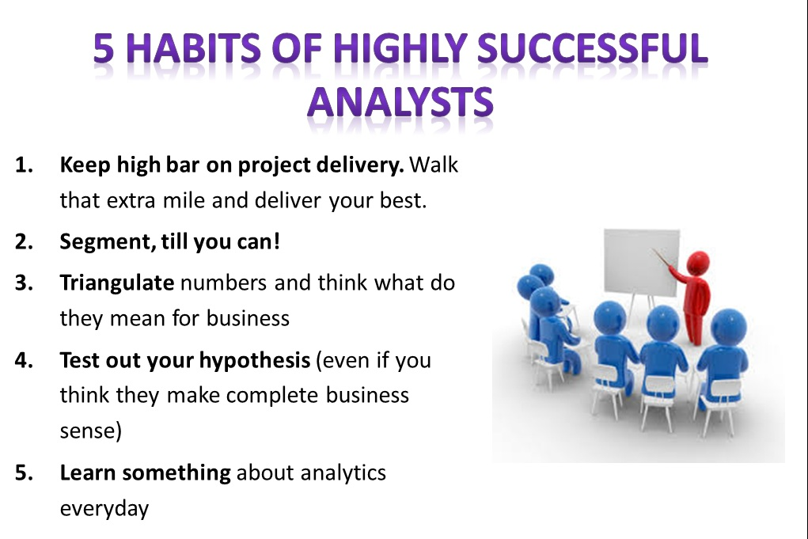

Habits of successful analysts

**Habit 1: Keep high bar on project delivery. Walk that extra mile and deliver your best**

Quality thinking differentiates a high performing analyst from a low performer. Successful analysts provide enough quality “brain time” to any project they deliver. By brain time, I mean distraction-free time devoted to analytical problem solving. This is the time when you strive for going beyond what is expected. This is the time when an analyst asks some of these questions to himself:

* Is there a better way to structure this problem? Will that make the solution better or more intuitive for business?
* Is there a better way to present / summarize the findings of the project? How can I visualize the outcomes in best possible manner?
* Instead of simply highlighting the insights from a project, can I use these insights and chalk out business actionables? Can I size the impact from these actionables and tell them to business upfront?
* Is there any aspect of analysis I might have ignored?
* Is there any implicit assumption I have made which is impacting the result?

**Remember, the value of analytics is recognized through the value it generates for the business and the amount of time spent asking these questions will have direct impact on the business value created**.

There have been times when I have changed the presentation flow, performed additional analysis, verified and re-verified all the numbers / insights till the night before project presentation. All of that is done to make sure the project creates the impact it deserves. And, nothing beats the feeling you go through after creating that impact.

So, don’t leave any stone un-turned and make sure there are no gaps in your thinking on every project you work on.

**Habit 2: Segment, till you can!**

Successful analysts never work on averages. Every time they see an average, they think if there is an underlying segmentation at work, which could explain things better? By not segmenting the average, there is value left on table. Successful analysts never do that.

[This](https://www.analyticsvidhya.com/blog/2013/08/importance-segmentation-create/) article contains various examples and the way to create a segmentation.

**Habit 3: Triangulate numbers, perform back of the envelope calculations and think what do they mean for business**

As an analyst, you deal with numbers day in and day out. You need to pick out that one cell in which the formula is wrong from a file containing thousands (if not millions) of formulas. The only way you can do it is by triangulating numbers and by making sense of what they mean for business.

While this might sound obvious, you will be surprised to see the number of times this is overlooked. While triangulating numbers deserves a post in itself, I’ll briefly mention some of the questions I ask to triangulate numbers:

* Ask yourself, can I reach this number through a different framework / calculation? Do the numbers tie up or they are different by a magnitude?
* Are there process dependencies which can give you a sense of numbers? Can you issue 2000 credit cards every month, if you only get ~1800 applications every month?
* What do these number mean for business? Do they tie in with the infrastructure and resources business has?

Triangulation is like any other skill, it will look difficult to start with. But the more you practice, the better you become at it.

**Habit 4: Test out your hypothesis (even if you think they make complete business sense)**

There are times when you tend to overlook the need for testing. Just adding a live chat functionality to your website? Sounds like a good thing to do with no down side. Test it out and you will know. The customers might not like it! Here is another example:

One of the leading travel portal in India saw this in their data: 90%+ flights booked have departing location same as city from which tickets are being booked (determined by the I.P. address). They thought of making this location pre-populated (obviously with an option to change). This sounds like a nice idea which would help provide a better customer experience. Thankfully, they tested it out. Booking conversion dropped by double digit percentage within weeks of making this change. **Possible reason:** The customers are used to filling To and From location. Removing one of them adds to the confusion.

So, next time if you are implementing results from any analysis or hypothesis, test it out!

**Habit 5: Learn something about analytics everyday**

While this habit will not bear immediate results like other habits mentioned above, you will benefit the most from this in long run. Analytics is a dynamic and evolving field. A new tool / technology / update arrives almost every 2 – 3 months. Being up to date with latest updates in industry helps not only stay on top of it, but creates a huge gap from analysts who don’t stay updated.

Some of the topics I enjoy reading whenever I get time are:

* What are the latest developments in Big data?
* How to analyze unstructured data from Social media? How can we make visualizing this better?
* What are the statistical concepts behind the algorithms used by various tools?
* How can you design and analyze a design of experiments?

The list is endless.

Start reading and you are bound to run out of time!

**Additional Habit:** One additional habit worth mentioning is **“Being customer centric”.**Hearing what the customers are saying and keeping that in mind is a trait of every successful professional. The same applies to an analyst. Since it is not an analytics specific habit, I have not mentioned it in the list.

While the list of habits could have been lot longer, I have deliberately restricted it to 5. If you think any other habit, please add them in comments.

# Tips to crack a guess estimate (Analytics case study)

[BUSINESS ANALYTICS](https://www.analyticsvidhya.com/blog/category/business-analytics/) [BUSINESS INTELLIGENCE](https://www.analyticsvidhya.com/blog/category/business-intelligence/)

SHARE

https://secure.gravatar.com/avatar/51bf7a2a1f2a0dd3a1012fa4cf5a9e80?s=48&d=mm&r=g [TAVISH SRIVASTAVA](https://www.analyticsvidhya.com/blog/author/tavish1/), JANUARY 6, 2014 / [39](https://www.analyticsvidhya.com/blog/2014/01/tips-crack-guess-estimate-case-study/#comments)

After a wait for 3 long hours, it was my turn to enter the interview room. The first question asked to me by the interviewer was “Can you estimate the total number of cigarettes consumed per month in India?” Having worked on a project for ITC in one of the core courses, I was able to crack the problem. I started with the total number of factories of ITC in India and calculated the number of cigarettes manufactured by ITC in a year with the help of average turnover time. Further, I made good guesses on the %cigarettes exported and the %share of ITC in India. Finally I got the number of cigarettes consumed per month in India which convinced the panel.

Such questions are very common in analytics and management consulting interview. If you wish to appear for companies of this genre, this article will be very useful. I was fortunate to have got this puzzle. What if I had no clue on the number of ITC factories producing cigarettes? After this interview I tried solving many such puzzles to get a comfort level with such problems. In this article I will walk through some techniques I now use to crack such puzzles.

**[stextbox id=”section”]What does interviewer evaluate using guess estimate case study?  [/stextbox]**

Very often in the role of Analyst and Consultant, clients expect quick initial scaling or sizing of potential projects. This is the reason that such questions are so common in interviews for recruitment of such roles. The interviewer is looking out for four key traits in this interview.

1. How structured is your approach?

2. How comfortable are you with numbers?

3. Are you able to make quick checks on the efficiency of different methods?

4. Can you do back of the mind calculations and validate the magnitude of numbers?

**[stextbox id=”section”]Framework to solve a guess estimate problem:  [/stextbox]**

Knowledge of certain techniques used for such guess estimates helps keeping the approach structured in the interview. Let’s address the cigarette estimate problem from the demand side (without using the number of ITC factories) while discussing the key techniques.  Following are the 4 key techniques which will help you in such case interviews :

[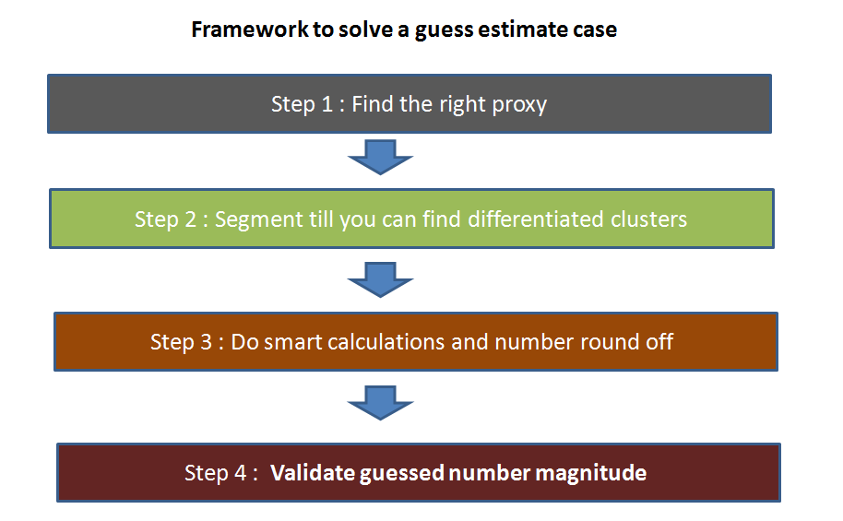](https://www.analyticsvidhya.com/blog/wp-content/uploads/2014/01/guess_framework.png)

1. **Find the right proxy**: This is by far the most important technique. The proxy is a parameter which behaves in a similar manner as the dependent parameter. In the cigarette estimation problem, the population of India is a good proxy for the number of cigarette consumed monthly in India.  If the population of India increases, it can be safely said that cigarette consumption will increase proportionally. Other proxies used is the growth in population, growth in demand of a newly introduced technology, average number of planes parked at major airports etc.

2.**Segment till you can find differentiated clusters**: Estimating parameters on a segment level is far more accurate than making guesses on the overall population. In the cigarette estimation problem, population below 16 years can safely be ignored for cigarette consumption and female population is expected to have a lower average cigarette consumption than male population. This is how segmentation helps making accurate assumptions.

3. **Do smart calculations and number round off** : Speed is very critical in such problems and one needs to maintain a balance between accuracy and time consumption. Say you need to fin 2999/3. It is much easier to calculate 3000/3 than 2999/3. In such cases right the answer as 1000 (-) . This indicates the number is slightly lesser than 1000 and can be compensated in further calculations.

4. **Validate number magnitude** : It is always a good idea to keep on validating intermediate numbers using your experience and sense checks.

**[stextbox id=”section”]Some ground rules to be followed while doing a guess estimate:  [/stextbox]**

Following are some factors one should keep in mind while solving a guess estimate problem :

1. Analyze all possible uses of the subject. For example, while estimating the number of tennis balls in India, one should consider balls being used in tennis, cricket and all other sports which are potential users of tennis balls.

2. Keep population of your country, state and city on finger tips. As population is the most common proxy for many case studies, such numbers give a good starting point.

3. Have a look on some key parameters for airline management : Many of guess estimate problems are related to airlines. A sense on the number of flights which normally stays in major airports, time lag between flight take off etc. helps.

4. Draw neat diagrams to show the segmentation. This not only helps do calculations quickly but also makes it easier to redo the calculations on the segment level if required.

5. Don’t do round off in the same direction. Such round off magnifies the error term. Putting a sign in front of rounded off number helps.

**[stextbox id=”section”]Step by step approach of solving a guess estimate problem : [/stextbox]**

**Case 1:** **Estimate the number of cigarettes consumed monthly in India**

**Solution:** A good proxy in such problem is the population of India i.e. 1.2 billion. Following is an effective way to segment this population:

[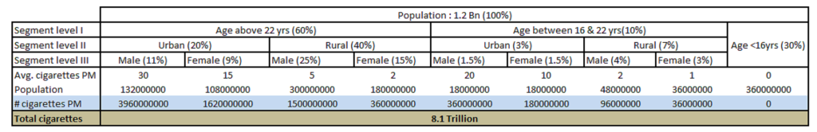](https://www.analyticsvidhya.com/blog/wp-content/uploads/2014/01/Guess1.png)

Following were the key considerations in building the segmentation and the intermediate guesses:

1. The rural population consumes far lesser cigarettes than urban because of the purchasing power difference.

2. Male consume more cigarettes than female in both urban and rural populations.

3. Children below 16 years consume a negligible number of cigarettes.

4. Male to Female ratio in Urban is closer to 1 than that of Rural.

5. Male to Female ratio in younger generations is closer to 1 than that of older. This is because of the increase in awareness level.

6. Bulk of population start smoking after getting into a job and hence the average number cigarettes are higher in older groups.

7. Total number of cigarettes from the supply side also come to around 10 Trillion, which gives a good sense check on the final number.

**Case 2:** **Estimate the number of WhatsApp Android application installed**

**Solution:** A good proxy in this problem is the world population i.e. ~7.2 Billion. Following is a possible approach to this problem :

[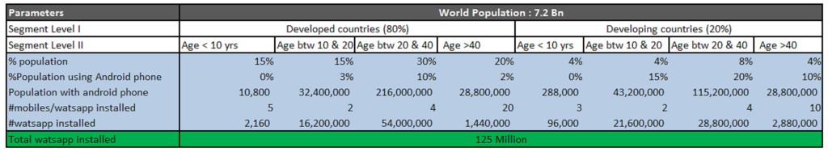](https://www.analyticsvidhya.com/blog/wp-content/uploads/2014/01/guess_case-33.png)

The actual number of Whatsapp installed on Android phone is slightly more than 100 Million. As can be seen from this example that guess estimates can be fairly accurate if we choose good segments and approximations.

**Case 3: Estimate the number of tennis balls bough in India per month**

**Solution:** A good proxy in this problem is the number of cities in India i.e. ~1700. The catch in this problem is to analyze where all can we use tennis balls. Once we have the number of tennis balls used monthly, we can easily find the number of tennis ball bought in a month using the lifetime of tennis balls.

Following is an effective way to segment this population:

[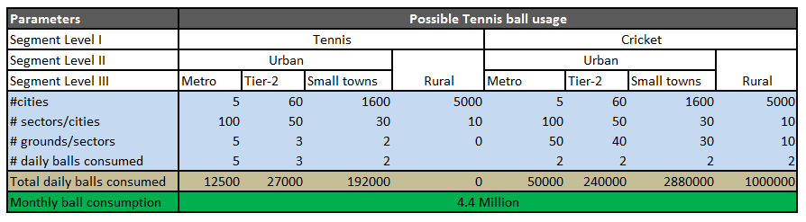](https://www.analyticsvidhya.com/blog/wp-content/uploads/2014/01/guess_case-2.png)

Following were the key considerations in building the segmentation and the intermediate guesses:

1. Rural areas have negligible number of tennis courts.

2. Metro cities have the highest number of sectors.

3. For each sectors in metro cities, the number of grounds for both tennis and cricket is higher. This is both because of the bigger area and the higher buying capacity in metros.

4.Number of balls consumed in metros per ground is higher because of the higher engagement in metros.

**[stextbox id=”section”]A challenge for the reader:  [/stextbox]**

Here is a practical example you can give a shot. Imagine you sitting in an interview and the interviewer asks “Estimate the number of aircrafts in air across the globe at this moment in time.” How will you answer this question ? Write down your approach in the comment box below to get opinion from experts.

**[stextbox id=”section”]End Notes:  [/stextbox]**

Guess estimates are one of the most common case studies asked in analytics interview. With right tools and techniques, this case study becomes a cake walk.

Did you find the article useful? Share with us any other techniques you incorporate while solving a guess estimate problem.  Do let us know your thoughts about this article in the box below.